**By 2721301**

Interesting Algorithms Design Document

# **Table of contents:**

**1.0 - Product Description** 2

1.1 - Broad Ideas 2

1.2 - Target Audience 2

1.3 - Personas 3

1.4 – Delivery 5

**2.0 - Design** 6

2.1 - Scenarios (PACT) 6

2.2 - Wireframe 8

2.3 – Navigation 14

2.4 - Design Choices & Justification 15

**3.0 - Prototype Description** 17

3.1 – What is the Same 17

3.2 - What Has Changed 17

**4.0 - Testing** 18

4.1 – Before Usability 18

4.2 – Usability Test Plan 19

4.3 – Continued Feedback 20

**5.0 - Sources** 21

# **1.0 - Product Description**

## 1.1 - Broad Ideas

As the demand for software related jobs increases, so does the number of newcomer’s interest in this subject. As someone who has been through this process, I have found a lot of the material available online quite interesting, but at the same time daunting and very hard for a newcomer to understand. Due to this, easier to understand resources should be available to novices to encourage them to try the subject. Considering all this I have decided to create a website that will introduce people just starting their software careers to searching and sorting algorithms.

The website is intended for people getting into software and just coming across algorithms, meaning it will be quite accessible and easy to understand. The site will show a range of different searching and sorting algorithms along with descriptions of how they work and what situations they are useful for. It will also have a range of interactive activities of algorithms in action to help them get a good idea of how they work in practice. The algorithms included in the site will be selection sort, merge sort, counting sort, bucket sort, radix sort.

## 1.2 - Target Audience

The target audience for this website mostly comprises of:

* Beginners in the subject – people who have a slight interest in software and algorithms and desire to learn more. They are assumed to have very slight technological skills and computer experience. They understand what data is but have just come across algorithms for the first time and want to understand more.
* Students in early years of study – This audience has completed at least a year of university and college.
* The majority I anticipate will be younger people (aged 15 to 25), but some outliers of mature students or older users also.

All users will have the same goal, which is improving their knowledge on algorithms, the website will be successful if the users leave with a better understanding of how they work. The material on this site will not be very complex meaning there isn’t much previous knowledge required and the majority of people will be able to learn something from this site.

## 1.3 - Personas

I have created two personas who will be using this product. The first persona is a new student trying to learn in advance for University, the other being a more experienced student requiring a refresher in algorithms.



Persona 1

Name: Emma Sloth

Quote: “It worked on my machine”

Description:

* Emma is a young student currently doing university from home due to coronavirus epidemic. As a result of this, Emma is experienced with self-research to get the answers she seeks. Emma has a great interest in computers and is an excellent coder, she has already excelled ahead of her peers and wants to be the best.
* Age: 21
* Role: Computing Science first year Student
* Sex: F
* Income: 0
* Hometown: Dundee, Scotland

Skills and knowledge:

* She has a basic understanding of code
* She currently understands hardware a lot more than software
* She is experienced with Java, HTML, CSS and PHP
* She can build basic applications and has an excellent understanding of data structures
* Was slightly introduced to algorithms at the end of her first year

Experiences: She has a year of computing experience from college, where she learned some basic coding. Emma has built a simple website

Family and Contacts: A mother, father, a sister and 2 dogs

Likes: Computers, harry potter, YouTube, technology, puzzles, reading books, frogs

Dislikes: Spiders, loud geese flying over her house

Habits: Emma has a habit of going down rabbit holes online, whether it be true crime or technology related, she finds a topic then continues to get deeper and deeper into it. Emma has a basic understanding of a lot of topics due to this which she likes to share with people. It is a good habit that helps accelerate her career in computing.

Persona 2

Name: Abigail Porter

Quote: “I can’t even remember what I had for breakfast”

Description:

* Abigail is a mature student who is also doing University from home. With the freer time this gives, Abigail has decided to undertake a personal project which would implement some sort of algorithm to deal with a set of data. Abigail has not always been into computers and decided to give software engineering a try. She is really enjoying it but is not very confident in her coding skills. She is a hard worker although very forgetful. She has a fear of falling behind and always requires refreshers every now and then.
* Age: 32
* Role: Computing Science third year Student
* Sex: F
* Income: 0
* Hometown: Stirling, Scotland

Skills and knowledge:

* She is experienced with coding
* She currently understands hardware a lot more than software
* She is capable in Java, C and python
* She used to have a good understanding of algorithms

Experiences: She has many years of self-teaching herself coding, she has created a range of different projects including a personal website, a database management system, an application displaying graphs and other graphics, a program for viewing available properties from a group of estate agents

Family: A mother, father, 4 brothers

Likes: Computers, cooking, baking, shopping, movies

Dislikes: Commitment, the dark, bees, beer

Habits: Abigail has a habit of biting her fingernails when she is nervous or stressed which doesn’t go well with her current course. She also has a bad habit of briefly skimming over everything she reads, not taking anything in, and then having to go back and read it again.

## 1.4 – Delivery

I have decided to use multiple different presentation methods to give users a fresh and unique experience for every different algorithm. When first accessing the site, the users will arrive to an introductory page explaining the purpose of the site, what it includes and what they can learn from it. Using the navigation bar, the users will be able to view the different pages on the site, each dedicated to one searching and sorting algorithm. The presentation methods are the following:

* A slideshow that users can progress through which will show algorithm being sorted. It will start as an unsorted set of data, and with each click through the slideshow will show the data sorting using this algorithm, until it has reached a fully sorted state
* A video page that shows a video of a sorting algorithm
* A canvas page showing the process of an algorithm getting sorted.
* An interactive animation page, the users can click to sort the algorithm
* A quiz page incorporating animation, the users will click the button that they think is the correct answer.

# **2.0 - Design**

## 2.1 - Scenarios (PACT)

Persona 1: Emma Sloth

Person:

* Emma is beginner level, but she is very intelligent
* She has a very high attention span and puts in the work to learn
* She has a great memory and a very fast learner
* Emma has no special needs or usability requirements
* Plans on frequently visiting website to keep learning

Activities:

* Emma is going through her first year of computing science at Dundee university
* She has briefly learned about searching and sorting algorithms
* She seeks more knowledge on these algorithms
* She wants to understand the different types and how they work
* She wants to be challenged and gain more knowledge
* She will gain the knowledge form the site, then use it to answer the final question correctly

Context:

* Emma is studying university from her home due to coronavirus
* She is just finishing her first year of university
* She has just come across searching and sorting algorithms for the first time
* She is trying to get ahead of her classmates before starting second year

Technology:

* Emma has just recently upgraded her computer and it is now very powerful
* She mostly uses this for high intensity gaming
* She owns a very large and high-tech monitor making everything very clear and visible
* The computer can handle any game, program or website

Persona 2: Abigail Porter

People:

* Abigail has quite a bit of experience with programming
* She is motivated to learn and pursue personal projects
* Does not have the best memory or attention span, but she tries hard
* Has dyslexia and finds it hard to read some things, needs larger text with high readability
* Only plans to visit the site once to find a solution to her problem

Goals:

* Abigail is creating a program that will at some point need to sort a set of data
* She has covered algorithms before in University, but she doesn’t fully remember them
* She needs a refresher in them as she needs to pick one out that will be suitable for sorting the set of data, she has
* She needs to know how searching and sorting algorithms differ for different situations
* She wants to learn about a broad range of algorithms that deals with different sets of data
* She will go through all the multimedia until she finds an algorithm that is suitable

Context:

* She is studying from home due to coronavirus
* She is halfway through her third year of University
* She is doing this over the winter break

Technology

* Abigail is using an old laptop which isn’t very powerful
* The laptop screen is very small which doesn’t go well with her dyslexia
* The computer may struggle with some sites

## 2.2 - Wireframe

I have created a wireframe that gives a basic idea of what will be one each page.

Introduction

This will be the main page for the site and the first page that the users arrive to. Every page after this will follow this similar template. At the very top there is a large heading with the name of the website “Interesting Algorithms”. Below that is the navigation bar that the users can use to click on any algorithm they like, at any time. Below that is a subheading which will be unique to every page, in this case it will say “Introduction”. Under this is a text box that will welcome users to the website and give them a small description of what the website is, and what they can do on it.

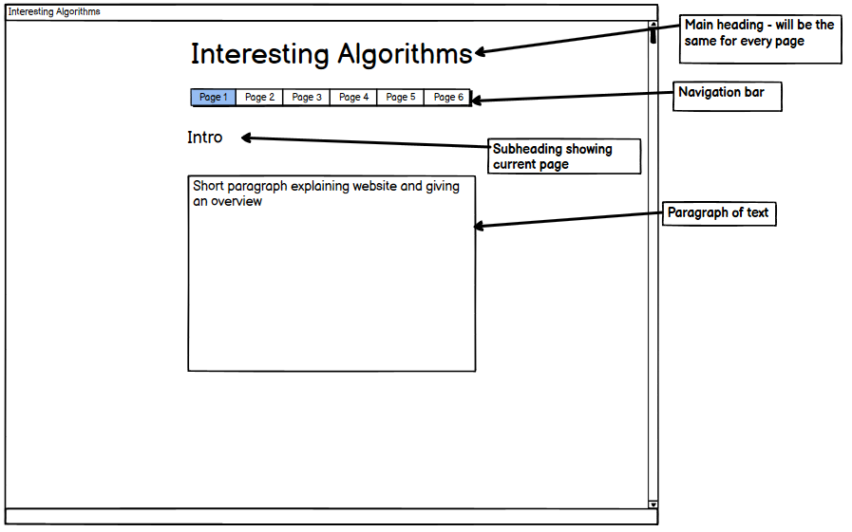

Slideshow Page

This is the first page containing an algorithm. The subheading will tell the user the algorithm they are looking at, and below will be a small description of it. It will keep it simple and give the user a basic idea of what this algorithm is, how it works and what situation it is best used for. Below that is a slideshow that shows the algorithm working on a set of data and sorting it. The user can click through the slideshow to watch it get sorted until it eventually completes. The slideshow has controls for it, a play button which will automatically go through the slideshow, a back button which will go back an image, and a forward button which will make it go the next image.

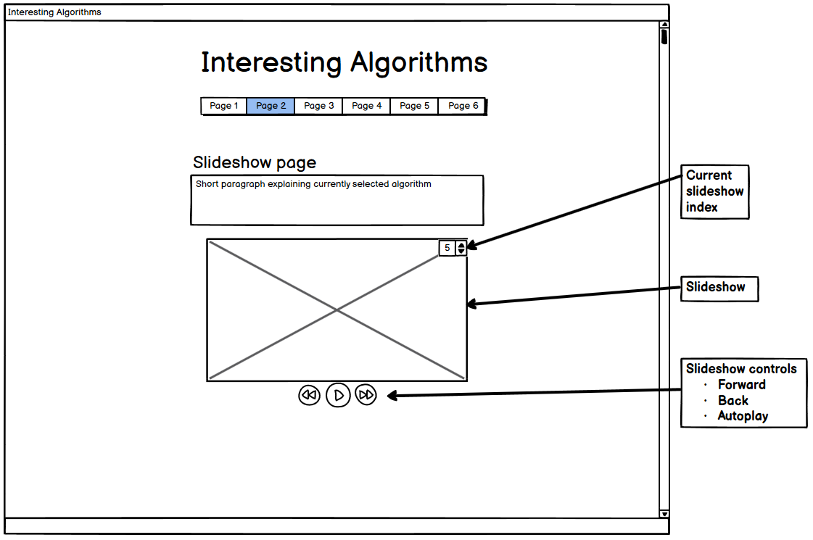

Video Page

This page has the same as the previous page except it has a video element to it. The video shows the algorithm being sorted and has some button controls to it. The pause/play button, a rewind button to put it back to the start, a seek bar that lets user skip through the video, a volume control button where it can be adjusted or muted and a full screen button that puts the video on fullscreen.

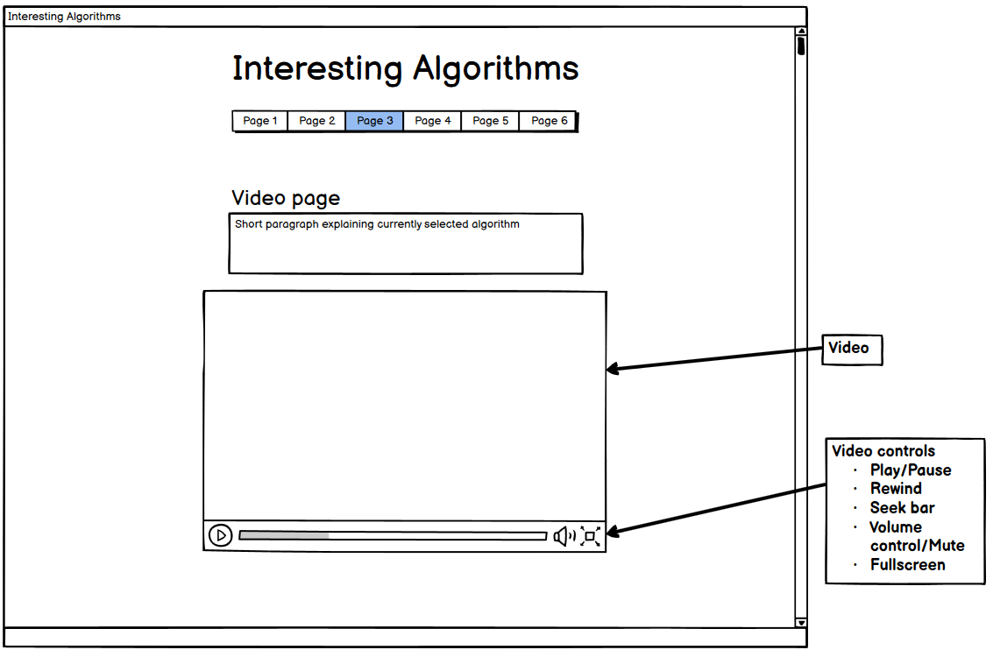

Canvas Page

The canvas stage will be similar however the canvas will show the stages of an algorithm being sorted until eventually completes. The user cannot interact with this page but only look at the process on the canvas.

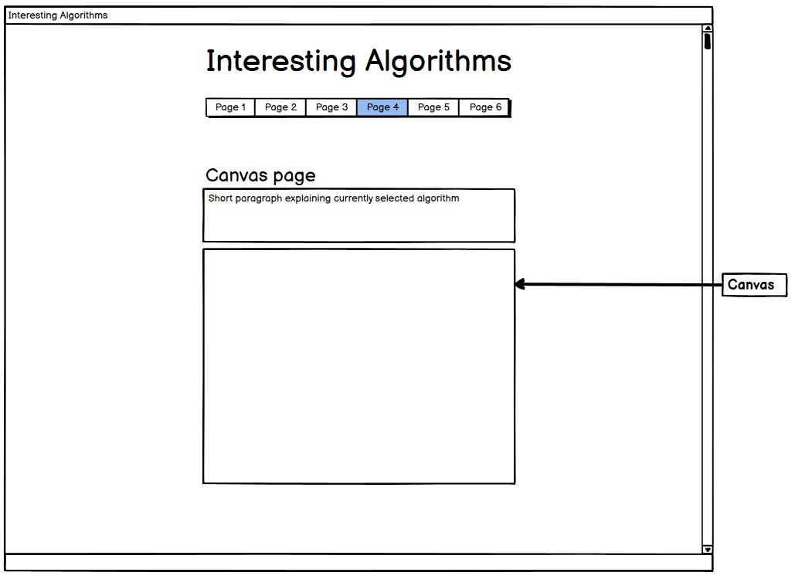

Animation Page

This page contains an animation that the users can interact with. It will initially show an unsorted set of data but prompts user to click the animation, every time the user clicks that data will sort using the specified algorithm until eventually reaching a fully sorted state.

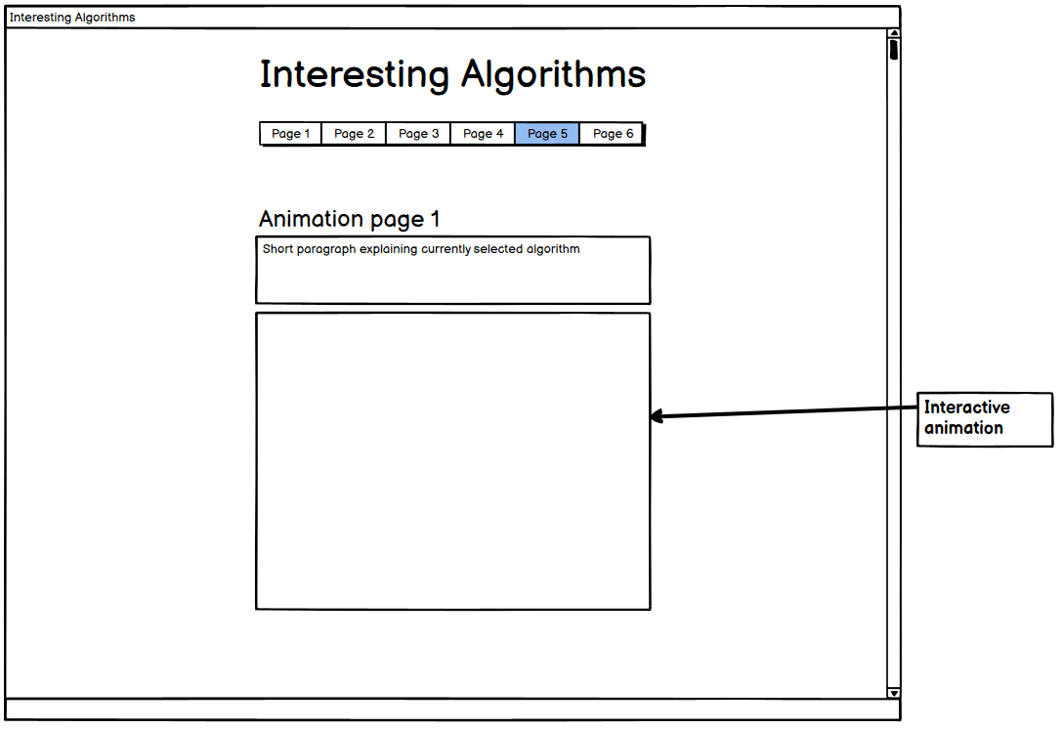

Quiz Page

This page also contains an animation but this time in the form of a quiz. This is so the user can test their knowledge on the current algorithm. They will be prompted with an easy question with multiple choice answers prompting them to click the correct one. If incorrect the box will highlight red and ask them to try again, if correct then the box will turn green and congratulate the user.

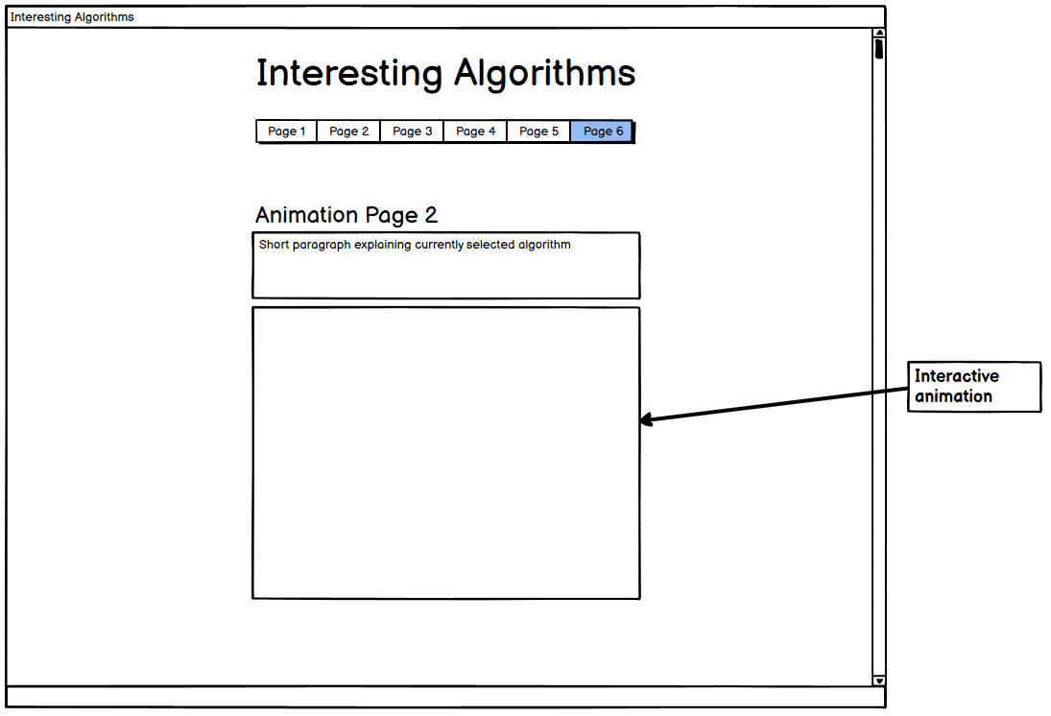

## 2.3 – Navigation

Navigating a website can often be confusing, badly designed navigation can end with the user getting lost and frustrated, causing them to leave the site for good. I have decided to keep navigation on my site very plain and linear to keep it simple for all users. My site has no need for a large hierarchy leading down multiple different paths but requires a simple one giving the users complete freedom on the site. The user will first start off on the introduction page, and from there they may go to any algorithm page they like. The pages are not in order and visiting later pages before the initial pages on the navigation bar will not affect the users experience on this site. Integrating this kind of navigation improves the efficiency of the site and the users can easily navigate back and forth between pages if they are looking for something. The navigation bar will keep the current page highlighted so users will always know where they’re at. Clicking a page on the nav bar will have a drop-down effect to give the website a professional and stylish feel to it.

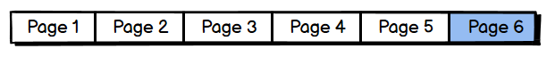This type of navigation will allow Abigail to quickly go back and forth to compare multiple algorithms, making it easier for her to determine which is suitable for her project. Emma may also briefly move on to another algorithm if she doesn’t fully understand the current one, allowing her to progress elsewhere before coming back to try again.

## 2.4 - Design Choices & Justification

Layout – I have designed my website to have a clean and professional look to it, I have avoided adding too much information on each page to prevent overloading the user. Rather I have decided to keep a lot of blank space on my pages, having the content of each page centred and slightly spaced out making it obvious to the user how they should progress through this page. As shown in an article on Seguetech, “whitespace not only creates harmony, balance and helps to brand a design, it can also be used to lead a reader from one element to another”. This professional look should inspire confidence in the user that this site will work as they expect it to. Each page will also be consistent and follow the same format as the one before, differences being the algorithm talked about and the accompanying media element. Having each page similar will make the user quickly comfortable with the site. After some research considering Abigail’s impairments, I have made the background of the site to a light cream colour instead of just plain black. Light cream increases readability for people with dyslexia as the content in front of it stands out more. To further help Abigail I have avoided using any difficult or awkward colour contrast and have decided to stick to dark on top of very light for all pages. Designing my site like this will attract the user attention to only the importing content of each page, with no unnecessary distractions.

Visuals – Visuals are a good way to get the audience’s attention, but a designer must be careful when using them. A study from ‘Behaviour & Information Technology’ determines that web designers have just “50 milliseconds to make a good impression” on users. This small amount of time determines whether the users will stay to use your website, or just instantly leave.

I wanted to use visuals to make the users interested in the site, but I kept the intensity down to a low amount. This is to avoid distracting and annoying users and had this be consistent for every page. On arrival to each page the user will immediately notice the large black bold titles using the font sans serif. Through looking at various popularity polls I found that sans serif gives a sleek and clean look making it a favourite for many professional sites such as LinkedIn. Below the Main site title, and navigation bar, there will be a sub-title for the current page. This will follow the same format as the main title but be slightly smaller to give the idea that it is nested within this page. Lower down the page will have the area containing the text that explains the current algorithm being talked about. I wanted to avoid having a big block of text that users can get lost in as it would be difficult for Abigail and her impairments, rather I spaced it out into small paragraphs making it easier to read. Key words in the paragraphs have been highlighted bold to convey importance as this should help users like Emma, who is new to the subject, take the information in easier and identify significant information. The main header will be large, subheading will be medium size, and the paragraph text will be much smaller as expected, but I wanted to keep it a decent size in order to keep readability. From “The Learn UI Design Blog” article on designing a responsive website they recommend body fonts to be at least 16px because it makes text readable from a device held at a comfortable distance from the user. Using px for font size makes the site responsive, the size of the text will scale will the device size and makes it available on almost all devices. The site will be created using a responsive bootstrap library making it easily scalable for any screen size. Adding this will also benefit Abigail as she has a small screen and can set her page size preference on her browser and the text will scale to suit her needs.

The metaphors found on this site include the side scroll bar, the slideshow left and right controls and the video controls, these are common across all site and the users should be familiar with how to use them. The affordances on this site are the navigation bar, the interactive animation, and the quiz at the end as the user will need a slight amount of guidance or visual cues on how to use them, but they are not complicated enough to require a full explanation.

# **3.0 - Prototype Description**

## 3.1 – What is the Same

The final version of my prototype contains all the pages from my initial design. The text and layout formats all follow what was previously decided as this was researched to fit the requirements of a persona. The media elements are present in all pages and they work as intended because this is the main part of each page and it is required for evaluation. Having most of the functionality to the site allowed me to go through it to see how I felt about each page and media element and how it added to the experience for the user.

## 3.2 - What Has Changed

Although it remains mostly the same, not everything from the design stage of my site has been implemented into the prototype. The website does not actually contain any information on algorithms, I have just added paragraphs of Greeked text to represent the information given. The multimedia tools do not represent the algorithm being shown, they are just examples of what the tools will be like. The final version of this site will contain very similar tools, but they will accurately show off the algorithm.

I decided to add a background colour behind the slide show as I didn’t like the amount of white space on this page, and I think it makes the controls more appealing and visible to the user. I also decided to just let the slideshow play automatically and I feel it gives the page a bit more life and feels active. Users can still use the controls to click backwards and forwards through the slides. The video element, canvas element and animation element all remain largely the same, however I have added a rotation animation to the quiz multiple choice answers as it makes the page more fun and satisfying when the user gets the correct answer. Other than this the final prototype is very much the same as my initial design.

# **4.0 - Testing**

## 4.1 – Before Usability

All website require testing before being released to the public, to ensure that everything works as intended and the website can be used by users to reach some sort of goal. A badly or incorrectly functioning site can instantly lose the trust new users, which could possibly turn them off from the site for good. This would lose many potential customers which would be detrimental to the success of the site. To conduct a basic test of the site I will first use white and black box testing.

The goal of white box testing is to check the basic functionality of the site. To begin with I first visited the introduction page where the users will first start on this site. I clicked through the navigation bar making sure it took me to my intended page. I then moved on to the first algorithm page which included a slide show and used the slideshow control buttons to check if it ran through the images as intended. After that I went to the algorithm page that includes a video, I checked that the video loaded correctly and watched it the full way through, then used the video control buttons to see it they would pause, play and rewind the video. I went on to the algorithm page that includes an interactive animation, which I clicked on and watched the animation run successfully. Finally, I went on to the quiz page and clicked through the multiple-choice answers, making sure the incorrect answers turn red and upside down, and the correct answer turned green and rotated.

Black box testing was then used to check the website with the specification to make sure everything matches up as intended. To begin with I checked if the layout of each page matches with the wireframe, and the background colour matches the one I chose in the design. After that I checked if all the text on the site matches the font I decided before hand, and that the size of the headings, subheadings and site body are the correct size. I ran through my user scenarios, reading the text on each page to make sure it made sense and was easy to understand. I checked to see if the media elements provided useful information to the page, and if viewing them gave a better understanding of the algorithm. I checked that the final quiz answer could be learned from the algorithm explanation to see if the users could successfully answer it.

## 4.2 – Usability Test Plan

As the designer and creator of the site, I cannot successfully test the site without having an insider biased. This means I will have to plan a test for the site using the expected target audience to test it. I have created the following test plan to be carried out:

1. With this test I will be trying to find out if the product is good enough and meets a professional standard. I want to know if the product is fit for its intended purpose and people can come visit it to gain knowledge on algorithms. I would like to find what users find out about algorithms and if they are satisfied with the website. I want to know if users prefer this site over competitors
2. 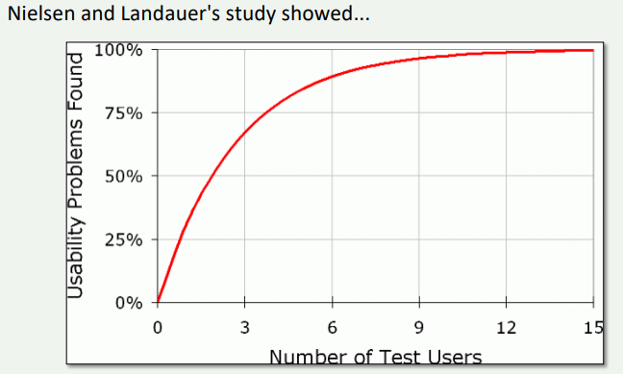The testers need will need to fit the target audience of this software, which would be novices that have a little understanding of computing. I will have a team of 10 testers, and I will split them up to do 2 separate tests, as this will give better results than having 10 people on the same test, shown in the following graph:

For both tests we will use the labs in Stirling University as they have comfortable facilities, and decent computers so the testers can get the full experience from the site.

There will be two types of tests carried out by the testers, the first being the Greeked layout test and the second being Krugs usability test. The first will test the layout of the page without considering the content provided, as it will all be turned into unreadable text. The aim of this is to have the testers identify all the elements on the page and navigate it without requiring help from that page. This ensures the site is easy enough to use. The second test will have the testers use the site, then go through a large amount of test questions giving their opinion for each. This will provide a lot of useful data on what the tester is thinking as they work their way through the site.

1. For testers I have asked a class from Stirling University currently in 2nd year of any computing course for any volunteers, before they have fully learned algorithms in their course to avoid biases.
2. I prepared all the equipment in the university lab, set up the computers onto the site that will be tested. All test supervisors in the room will know what the user’s goals should be, and will be on standby if they require help
3. The test will then be running after telling the users what their goal is, which is either identifying the elements on each page with unreadable text or filling out the questions on a sheet provided.
4. I will give my testers a big thank you and pay them for their time.
5. I will collect the data and use it to determine if my website was successful or not. I will see if the users did manage to navigate around my site successfully and understand what each area was for even though the text was unreadable. I will find if they managed to distinguish heading, subheading, navigation bar, the main content of each page and correctly work the multimedia elements without any clues. I will also get the answers for the Krugs test to get the testers comments on the site as the progressed through it and interact with it.

## 4.3 – Continued Feedback

To get continued feedback on this site I will conduct some online testing. The top of my page will display a link to a questionnaire asking users if they complete it. The questionnaire will contain different statements about the site and how users feel about it, what they think it does well and what it could use more of. The answers will be on a scale of 1 to 5 on how they feel about each statement, with an optional box for comments below it. This is an easy method to get a large amount of feedback from users over a period, allowing the site to be adjusted to add new features or fix certain bugs incrementally.

# **5.0 - Sources**

ProtoFuse, Inc. (n.d.). *Is a Poor Visual Design Killing Your Website?* [online] Available at: https://www.protofuse.com/blog/details/is-a-poor-visual-design-killing-your-website/ [Accessed 10th Oct. 2020].

Lindgaard, G., Fernandes, G., Dudek, C. and Brown, J. (2006). Attention web designers: You have 50 milliseconds to make a good first impression! *Behaviour & Information Technology*, 25(2), pp.115–126. [Accessed 10th Oct. 2020].

www.awwwards.com. (n.d.). *20 Best Google Web Fonts*. [online] Available at: https://www.awwwards.com/20-best-web-fonts-from-google-web-fonts-and-font-face.html [Accessed 10th Oct. 2020].

W3.org. (2012). *Optimal Colors to Improve Readability for People with Dyslexia - Text Customization for Readability Online Symposium*. [online] Available at: <https://www.w3.org/WAI/RD/2012/text-customization/r11>. [Accessed 10th Oct. 2020].

learnui.design. (n.d.). *Font Size Guidelines for Responsive Websites (2020 Update)*. [online] Available at: https://learnui.design/blog/mobile-desktop-website-font-size-guidelines.html#:~:text=Text%20input%20sizes%20should%20be [Accessed 10th Oct. 2020].

hci.ilikecake.ie. (n.d.). *PACT Analysis*. [online] Available at: <http://hci.ilikecake.ie/requirements/pact.htm>. [Accessed 10th Oct. 2020].

Usability test script. (n.d.). [online] Available at: <https://www.sensible.com/downloads/test-script.pdf>. [Accessed 10th Oct. 2020].

www.quicksprout.com. (n.d.). *A Simple Guide to Website Usability – 2020 Best Practices*. [online] Available at: <https://www.quicksprout.com/website-usability/>.[Accessed 10th Oct. 2020].

Segue Technologies. (2015). *Why Whitespace is so Important in Web Design*. [online] Available at: https://www.seguetech.com/whitespace-web-design/#:~:text=Whitespace%20not%20only%20creates%20harmony [Accessed 9 Nov. 2020].

‌